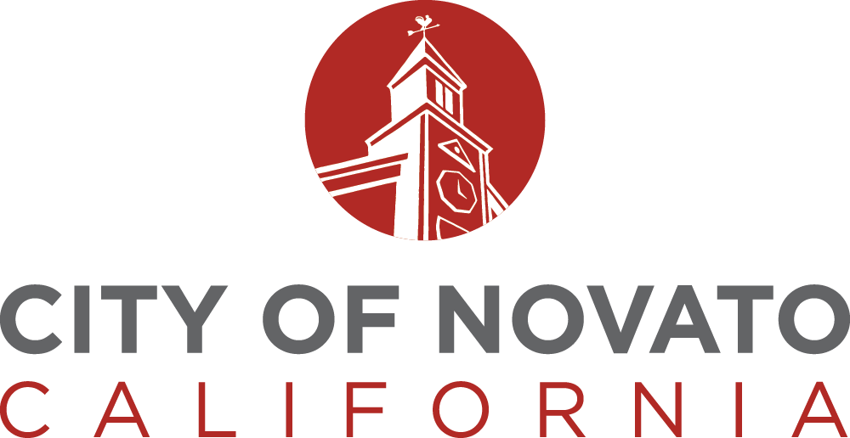

**Sustainability Commission**

**AGENDA**

**Thursday, April 20, 2023 - 6:00 p.m.**

Novato City Hall, 901 Sherman Avenue

**\*\*\* MEETING CANCELLED DUE TO LACK OF QUORUM \*\*\***

|  |  |
| --- | --- |
| **AFFIDAVIT OF POSTING**  I, Monica Castillo, certify that on April 13, 2022, the agenda was posted on the City Community Service Board at 922 Machin Avenue and on the City’s website [www.novato.org](http://www.novato.org).  / Monica Castillo /  Gretchen Schubeck, Senior Office Assistant | |
|  |
|  |